Guía de aprendizaje #5

Alejandro Javier Arevalo Milián

1. 4-1

F1=A+B´C+BD´+ B´D

F2=A´B+D

T1=B´C

T2=A´B

T3=A+B´C

T4=BD´+B´D

|  |  |  |  |  |
| --- | --- | --- | --- | --- |
| A | B | C | D | F |
| 0 | 0 | 0 | 0 | 0 |
| 0 | 0 | 0 | 1 | 1 |
| 0 | 0 | 1 | 0 | 1 |
| 0 | 0 | 1 | 1 | 1 |
| 0 | 1 | 0 | 0 | 1 |
| 0 | 1 | 0 | 1 | 0 |
| 0 | 1 | 1 | 0 | 1 |
| 0 | 1 | 1 | 1 | 0 |
| 1 | 0 | 0 | 0 | 1 |
| 1 | 0 | 0 | 1 | 1 |
| 1 | 0 | 1 | 0 | 1 |
| 1 | 0 | 1 | 1 | 1 |
| 1 | 1 | 0 | 0 | 1 |
| 1 | 1 | 0 | 1 | 1 |
| 1 | 1 | 1 | 0 | 1 |
| 1 | 1 | 1 | 1 | 1 |

1. 4-2

F=ABC+A´D

G=ABC + A´D´

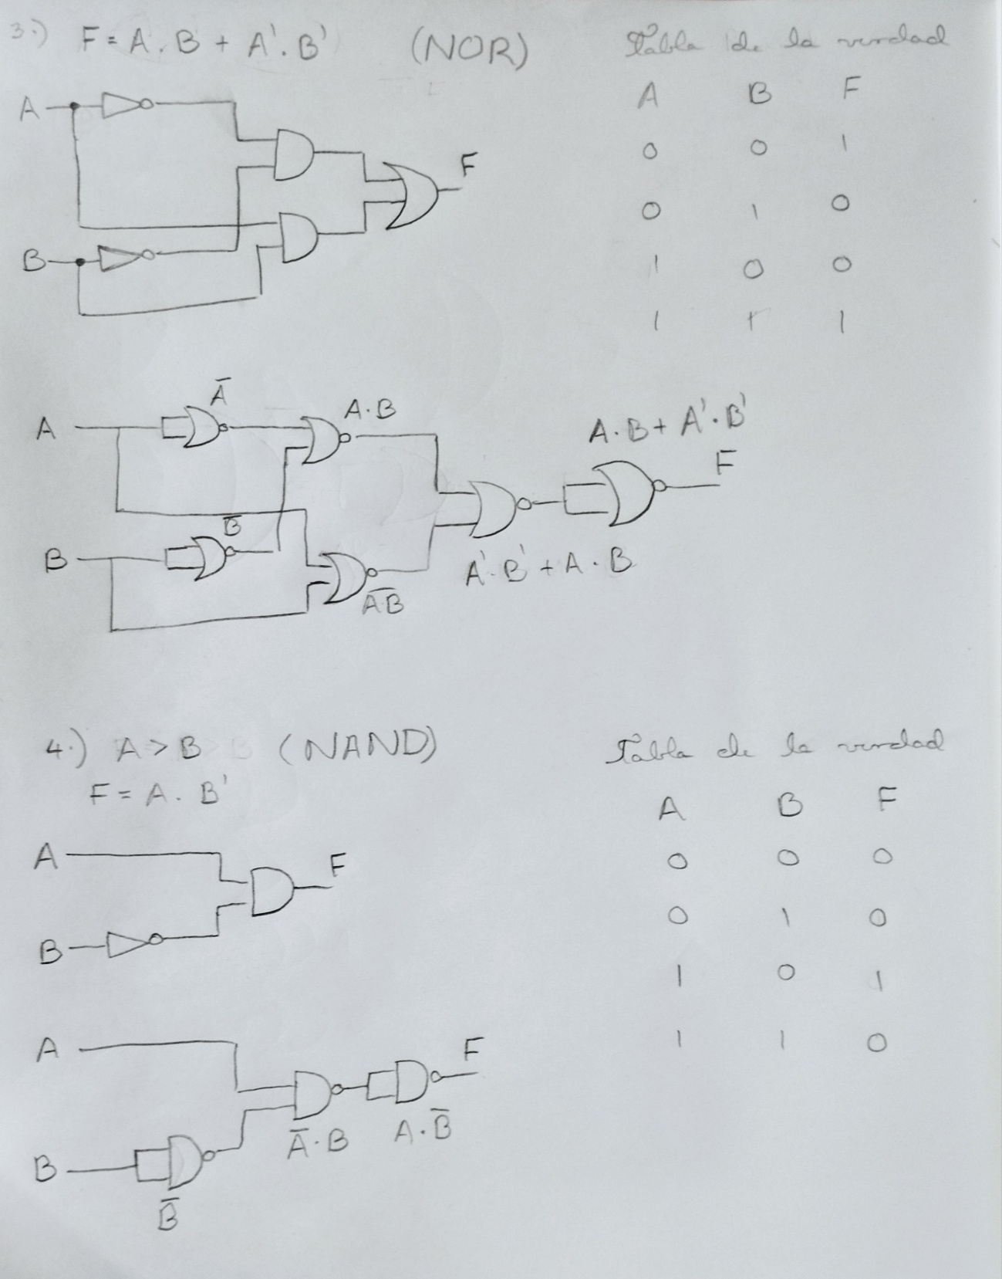

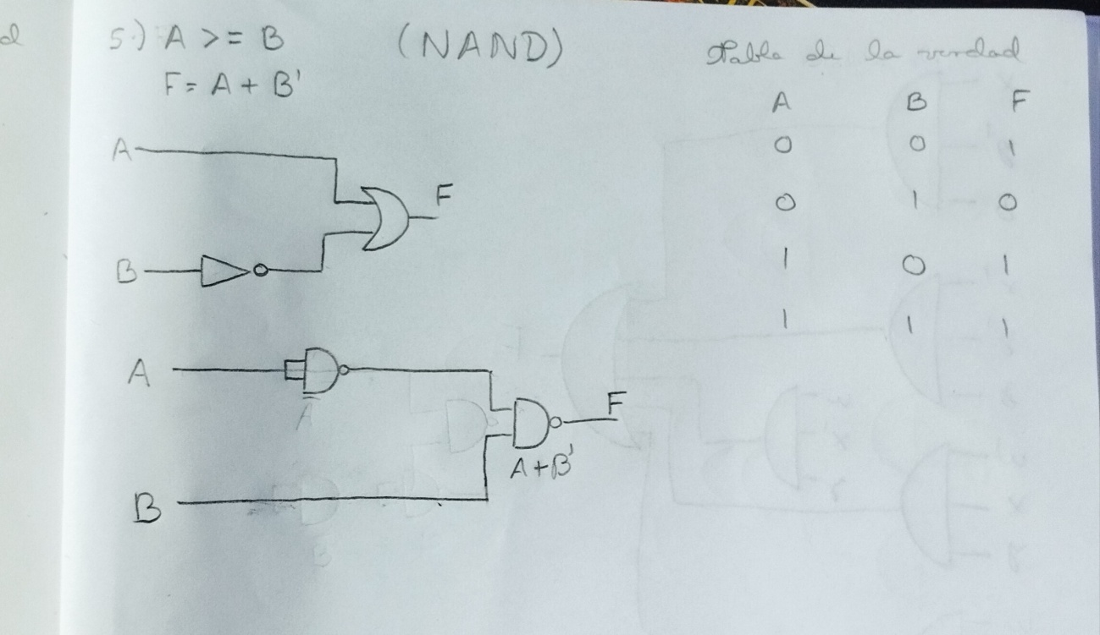

Además subi los mismos proyectos al Github realizados en proteus para que pueda ver su correcto funcionamiento.